

**US Army Corps of Engineers**

**Afghanistan Engineer District**

AED Design Requirements:

Sanitary Sewer & Septic System

Various Locations, Afghanistan

September 2009

Version 1.5

**TABLE OF CONTENTS**

AED DESIGN REQUIREMENTS FOR

SANITARY SEWERS & SEPTIC TANKS VARIOUS LOCATIONS, AFGHANISTAN

**Section Page**

**1. General 5**

**2. Field Investigations 5**

a) Site Survey 5 b) Percolation testing 5

**3. Sanitary Sewer System 8**

a) Sanitary Sewer System Layout 8 b) Protection of Water Supplies 8 c) Quantity of Wastewater 9 d) Gravity Sewers 9 e) Pipe, Fittings and Connections 11 f) Manholes 12 g) Building Connections and Service Lines 12 h) Cleanouts 12 i) Grease Interceptors 12 j) Oil Water Separators 13 k) Field Tests and Inspections 13

**4. Septic System 13**

a) General 13 b) Septic Tank 13 c) Absorption Field 14 d) Pressure Dosing of Leach Fields 18 e) Seepage Pits 29

**5. Design Submittal Information 30**

**6. As-Builts 31**

**Tables Page**

Table 1. Minimum Slopes for Sewers 11

Table 2. Soil Treatment Areas in Square Meters 17

Table A-1. Orifice Diameter 24

Table A-2. Friction loss in plastic pipe 26

Table A-3. Friction losses through plastic fittings 26

Table A-4. Void Volume for various diameter pipes 27

Table 7-6. Sidewall Areas of Circular Seepage Pits 30

**Figures Page**

Figure 1. Percolation Testing 7

Figure 2. Schematic Pipe Definitions 11

Figure 3. Pressure Distribution System 19

Figure 4. Typical Pressurized Flow Distribution Device 20

Figure 5. Typical Flow Distribution Valve 20

Figure 6. Orifice Spacing 23

Figure 7. Example of a Dosing Tank 28

Figure 8. Seepage Pit Cross Section 29

**Examples Page**

Example 1: Calculating Percolation Rates 6

Example 2: Size of a Septic Tank 14

Example 3: Size of an Absorption Field 16

Example 4: Size a Pressure Distribution Network 22

Example 5: Size of a Seepage Pit 30

**Appendix**

Appendix A - Example Gravity Sewer Calculation

Appendix B – Drawing Details

Septic Tank Details

Absorption Bed and Trench Details

Dosing system Layout

**1. General**

The purpose of this document is to provide requirements to Contractors for any project requiring sanitary sewer and septic system design and construction. Effluent disposal is provided by leach fields. Septic systems are considered appropriate where the native soil conditions natural percolation properties provide biological treatment of the wastewater after receiving primary treatment in a septic tank. Because of leach field size constraints and uniform distribution of effluent within the leach is more difficult with larger sites, septic tank and leach field systems are limited to projects where the total effective design population is less than 300 personnel. Depending upon the water usage rate adopted for the project, this is typically an average daily flow rate of approximately 55,800 to 68,400 liter per day (14,700 to 18,000 gallons per day)

assuming 80% wastewater generated from water usage and a capacity factor of 1.5 for treatment.

Holding tanks may be authorized as an alternative to effluent disposal means in the project contract technical requirements. Because the costs of hauling wastewater and the uncertainty in its sanitary disposal once offsite are greater, holding tanks should be limited to smaller installations when no other alternatives are possible. The break even cost for package WWTP construction and annual operating cost versus the annual septage hauling cost for holding tanks indicates that installations having design populations in excess of approximately 200 to 250 personnel would be better served by a package WWTP provide sufficient land and effluent disposal means are available.

**2. Field Investigations**

**a) Site Survey**. The first step, when designing the sewer system, is determining existing site conditions. The existing site conditions shall be determined by conducting field investigations at the proposed site. As part of the field investigations, the Contractor shall conduct a topographic survey to determine existing site characteristics. Knowing this information will help determine whether a gravity system or a pressure system will be used and where to locate the septic system. In addition, the Contractor shall conduct a utility survey to determine the locations of any nearby water lines, wells, sanitary sewers, storm sewers and electrical lines. By knowing the location of the existing utilities, the Contractor can properly lay out the system.

**b) Percolation Testing.** The second step, once the site has been surveyed, is to perform percolation tests. While performing the tests, observe the soil characteristics and watch for groundwater within the test area. The site may be considered unsuitable if the following occurs: the soil appears to have too much sand or clay; groundwater is encountered; and/or the percolation rates are too slow. If the site is determined to be unsuitable, the septic system will need to be relocated. If another location cannot be found, then an alternative treatment system will need to be designed. If this happens, contact the COR.

Percolation testing may be carried out with a shovel, posthole digger, solid auger or other appropriate digging instruments. Percolation tests shall be accomplished uniformly throughout the area where the absorption field is to be located. Percolation tests determine the acceptability of the site and serve as the basis of design for the liquid absorption. Percolation tests will be made as follows (see Figure 1).

(1) Six or more tests will be made in separate test holes uniformly spaced over the proposed absorption field site. The average of the six tests shall be determined and will be used as the final result. ***The location of each test shall be clearly and accurately shown on the site plan submitted to AED***.

(2) Dig or bore a hole to the required depth of the proposed trenches or bed, with dimensions necessary to enable visual inspection during percolation testing.

(3) Carefully scratch the bottom and sides of the excavation with a knife blade or sharp- pointed instrument to remove any smeared soil surfaces and to provide a natural soil

interface into which water may percolate. Add 50 mm of gravel (of the same size that is to be used in the absorption field) to the bottom of the hole. In some types of soils the sidewalls of the test holes tend to cave in or slough off and settle to the bottom of the hole. It is most

likely to occur when the soil is dry or when overnight soaking is required. The caving can be prevented and more accurate results obtained by placing in the test hole a wire cylinder surrounded by a minimum 25 mm layer of gravel (of the same size that is to be used in the absorption field.)

(4) Carefully fill the hole with clear water to a minimum depth of 300 mm above the gravel or sand. Keep water in the hole at least 4 hours and preferably overnight. In most soils it will be necessary to augment the water as time progresses. Determine the percolation rate 24

hours after water was first added to the hole. In sandy soils containing little clay, this pre- filling procedure is not essential and the test may be made after water from one filling of the hole has completely seeped away.

(5) The percolation-rate measurement is determined by one of the following methods:

(a) If water remains in the test hole overnight, adjust the water depth to approximately 150 mm above the gravel. From a reference batter board, as shown in Figure 1, measure the drop in water level over a 30-minute period. This drop is used to calculate the percolation rate.

(b) If no water remains in the hole the next day, add clean water to bring the depth to approximately 150 mm over the gravel. From the batter board, measure the drop in water level at 30-minute intervals for 4 hours, refilling to 150 mm over the gravel as necessary. The drop in water level that occurs during the final 30-minute period is used to calculate the percolation rate.

(c) In sandy soils (or other soils in which the first 150 mm of water seeps away in less than 30 minutes after the overnight period), the time interval between measurements will be taken as

10 minutes and the test run for 1 hour. The drop in water level that occurs during the final 10 minutes is used to calculate the percolation rate.

The percolation rate is the number of minutes it takes to drop 25 mm. On page 10, Table 2 lists percolation rates and the corresponding absorption field sizing factor (liters/m2/day). The sizing factors are used, in conjunction with average daily demand (ADD), to determine the size of the absorption field. The following is an example of how to calculate the percolation rate:

***Example 1: Calculating Percolation Rates - In 30 minutes, the measured drop in the water level is 15 mm.***

*Minutes/25 mm = Time/(drop/25 mm) = 30 minutes/(15 mm/25 mm) =*  ***50 Minutes/25 mm***

*where,*

*Minutes/25 mm = Minutes for water to drop 25 mm.*

1\en lbkln( f'1rcoti!IC1'1

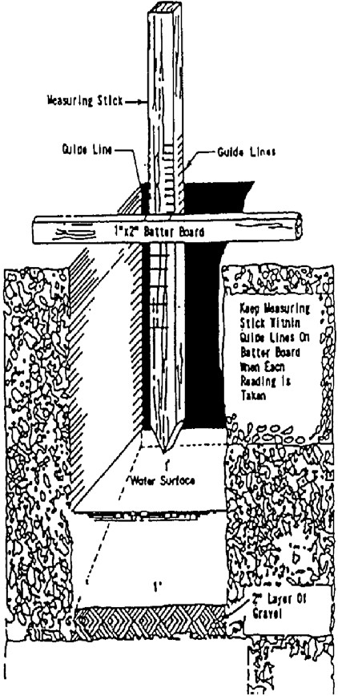

Tuu lbrlLines Holn 11

SJIH Tin ln t erwah

MOTE: Kl. LEAVE BHHR SOARD IN PUCE.

BE CAREFUL NOT TO MOVE IT

OURIMC USE .

ltlen lbktnr Pmolllloo Tuts lbrt Unu H4u1t Rei)llll 111111 lntmals

.,

ce·

;c:

,""""

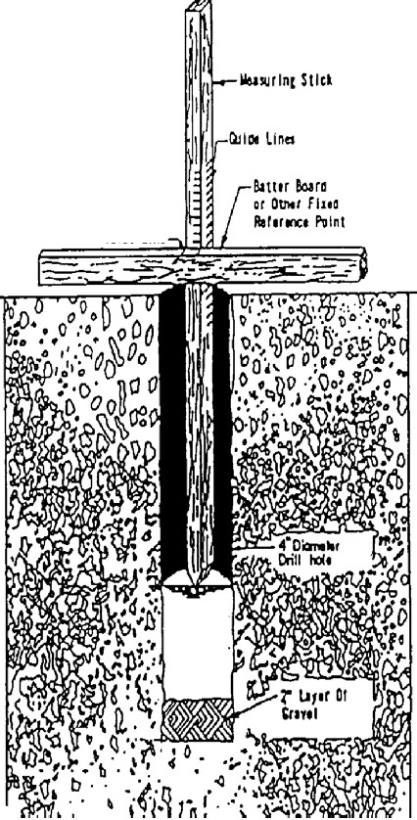

(I)

ri

!2..

0

::I

-1

(I)

.....

*HOlE:* In Jolts lflm stCII Int slau *au melt* to ocOJr,

the uu ol a •Ire C191 to tn• totterar tne holl .•1 Ill

a •lniM at 1 Inaor rruel UIUld tn e earw •Ill

rhld rurlslic rtsults, QJiae Line

FlosNIQhl rntJy be u IO t ly Mol 111101\Kii"Q sllek ol .,.o ttf swfoee,

c:p:I

*fU*

::I;:l>

»m

c

(J)C

(I) (I)

:e

!!!.

C..D, I::CI

Qo:;u

_g

'S !;,

c;·;

i

a

(I) Ill

3

Ill

**3. Sanitary Sewer System**

**a) Sanitary Sewer System Layout.** The development of the sewer system (a.k.a. - sanitary pipe collection network) must await the determination of the proposed compound layout, including determining locations for: buildings (including final first floor elevations and utility connections), perimeter wall, and roads, water well, septic system, power supply system, storm drainage and other features. Once the locations for these structures are determined, the Contractor can begin designing the layout of the sanitary sewers in conjunction with the water supply system. The following general criteria will be used where possible to provide a layout which is practical and economical and meets hydraulic requirements:

(1) Follow slopes of natural topography for gravity sewers.

(2) Check subsurface investigations for groundwater levels and types of subsoil encountered. If possible, avoid areas of high groundwater and the placement of sewers below the groundwater table.

(3) Avoid routing sewers through areas which require extensive restoration or underground demolition.

(4) Depending upon the topography and building location, the most practical location of sanitary sewer lines is along one side of the street. In other cases they may be located behind buildings midway between streets. The intent is to provide future access to the lines for maintenance without impacting vehicular traffic.

(5) Avoid placing manholes in low-lying areas where they could be submerged by surface water or subject to surface water inflow. In addition, all manholes shall be constructed 50 mm higher than the finished grade, with the ground sloped away from each manhole for drainage.

(6) Sewer lines shall have a minimum of 800 mm of cover for frost protection.

(7) Locate manholes at change in direction, pipe size or slope of gravity sewers.

(8) Sewer sections between manholes shall be straight. The use of a curved alignment shall not be permitted.

(9) If required by the design, locate manholes at intersections of streets where possible. This will minimize vehicular traffic disruptions if maintenance is required.

(10)Sewer lines less than 1.25 meters deep under road crossings shall have a reinforced concrete cover of at least 150 mm thickness around the pipe or shall utilize a steel or ductile iron carrier pipe. It is recommended to continue the reinforced concrete cover or carrier pipe a minimum of one (1) meter beyond the designated roadway.

(11)Verify that final routing selected is the most cost effective alternative that meets service requirements.

**b) Protection of water supplies**. Sanitary sewer design shall meet the following criteria:

(1) Sewers shall be located no closer than 15 meters measured horizontally to water wells or earthen reservoirs that are used for potable water supplies.

(2) Sewers shall be located no closer than 3 meters measured horizontally to potable water lines; where the bottom of the water line will be at least 300 mm above the top of the sewer line, the horizontal space shall be at a minimum of 1.83 meters.

(3) Sewer lines crossing above potable water lines shall be constructed of suitable pressure pipe or fully encased in concrete for a distance of 3 meters measured horizontally on each side of the crossing. If concrete encasement is used, the sewer line shall be encased with a minimum of 150 mm of cover all the way around the pipe. Pressure pipe will be as required for force mains in TM 5-814-2/AFM 88-11, Chapter 2, and shall have no joint closer than 1 meter horizontally to the crossing, unless it is fully encased in concrete.

**c) Quantity of Wastewater**. The design of the wastewater system shall be based on two factors: the average daily flow and the peak diurnal flow (PDF).

(1) Average Daily Flow (ADF). The Contractor shall verify the average daily flow considering both resident (full occupancy) and non-resident (8hr per day) population. The average daily flow will represent the total waste volume generated over a 24-hour period, and is defined as 80% of the product of the total population of the facility (c), the per capita water usage rate per day

(ADD) , and the applicable capacity factor (CF) (0.8* c*ADD*CF). The capacity factor for installations with populations less than 5,000 residents is 1.5. Capacity factors for larger installations shall be determined using Chapter 4 Basic Design Considerations, UFC 3-240-09FA Domestic Wastewater Treatment, Table 4-1. For example, the average daily flow at a compound with a population of 500 personnel, would be calculated by multiplying the population (500) by the water usage rate (190 lpcd) by the capacity factor (1.5) by 80% resulting in a flow of 114,000 liters/day (30,160 gallons per day)..

(2) Peak diurnal rates (PDF) of flow occur on a daily basis and must be considered. The sewer shall be designed with adequate capacity to handle these peak diurnal flow rates. The peak diurnal flow rate is computed by the following equation:

PDF= __Q_C

2Q0.167

Where PDF = Peak diurnal flowrate

Q = Average daily flow in gallons per day (including the capacity factor) C = 38.2 for gallons per day

So for the same compound with a population of 500 personnel, the peak diurnal flow rate would be the 114,000 liters/day (calculated above multiplied by 38.2 divided by 2 times (30,160)0.167 which equals 389,027.3 liters per day.

**d) Gravity Sewers.** The method for designing the sanitary sewers shall be determined according to the installation population.

(1) For installations with populations less than 450 personnel, all sewer pipe slopes shall be a minimum of 1.0%, regardless of pipe size. If a lift station becomes necessary due to this 1% slope, and the depth of the septic tank is too deep to allow gravity flow to the absorption field, then the designer should contact AED immediately to discuss options.

(A) Minimum Pipe Diameter. The minimum pipe diameter used in the sewer system for this size installation (after the building plumbing connection) shall be 150mm. This diameter pipe may be used throughout the installation. This shall be the minimum size. Larger pipe diameters may be used, but should be used only if flows require a larger diameter.

(2) For installations with populations greater than or equal to 450 personnel the sanitary sewer shall be designed to meet the following conditions. If, based on the following conditions, it is determined that a lift station is necessary to meet the flow and pipe size requirements than the designer should contact AED immediately.

(A) Peak Diurnal Flow (PDF). Piping shall be designed to provide a minimum velocity of

0.6 meters per second (mps) or (2.0 feet per second (fps) and shall NOT flow at greater than 80% full or at a velocity greater than 3.0 mps (10 fps). It is required that all the pipes are designed to achieve a scouring velocity of 0.6 mps at the PDF.

(B) Average Daily Flow (ADF). When possible, piping shall be designed to provide a minimum scouring velocity of 0.6 mps ( 2.0 fps) at the ADF, and shall NOT flow at greater than

80% full or at a velocity greater than 3.0 mps (10 fps) in every segment of the sewer system. It is preferred that the scouring velocity be achieved by the ADF however it is not a requirement

(C) Flow Allocation. Flows in laterals, mains and trunk lines shall be based on allocating

the proportion of the average daily and peak diurnal flow to each building or facility on the basis of the drain fixture unit flow developed for the plumbing design. [**For example**, consider a lateral receiving flow first from building A, then from building B and then from building C prior to

emptying into a main. These buildings have drain fixture units of 10, 25, and 5, respectively. The entire facility has a total of 6 building and a total of 80 drain fixture units. The flows used to

design the lateral receiving flow from building A would be 10/80 times the ADF and the PDF. The flows used to design the lateral after receiving flow from buildings A and B would be (10+25)/80 times the ADF and the PDF. Finally, the flows used to design the lateral after receiving flows

from buildings A, B, and C would be (10+25+5)/80 times the ADF and the PDF.]

(D) Minimum Pipe Slopes. Table 1 defines the minimum pipe slopes allowed in the sewer system. These shall be the minimum provided, regardless of the calculated flow velocities to prevent settlement of solids suspended in the wastewater. Table 1 does not apply to building connections.

(E) Building connection. Sewer lines from buildings will be designed to provide a minimum velocity of 0.6 meters per second or 2.0 feet per second at the drain fixture unit flow for that building. The building connection is the pipe from the building to a manhole or pipe that has more than one pipe entering it, see Figure 2. The minimum slope of building connection shall be

1% regardless the size of the installation.

(F) Minimum Pipe Diameter. The minimum pipe diameter used in the sewer system (after the building plumbing connection) shall be 150mm. These sizes shall be provided regardless of flows being received. Larger pipe diameters shall be provided in the sewer system based on flow and velocity requirements.

Unless otherwise indicated (see Paragraph 3 (g) Building Connections and Service Lines below), gravity sewer pipe shall be installed in straight and true runs in between manholes with constant slope and direction. Pipe slopes shall be sufficient to provide the required minimum velocities and depths of cover on the pipe. Table 1 below provides the minimum allowable slopes for various diameter pipes. Table 1 does not apply to installations with populations less than 450 persons. The minimum slope for 150mm piping at these installations is to be 1%.

**Table 1. Minimum Slopes for Sewers (Populations**

**Greater than 450).**

|  |  |
| --- | --- |
| Sewer Size | Minimum Slope in Meters per 100 Meters |
| 100 mm | 1.00 |
| 150 mm | 0.62 |
| 200 mm | 0.40 |
| 250 mm | 0.28 |
| 300 mm | 0.22 |
| 350 mm | 0.17 |
| 375 mm | 0.15 |
| 400 mm | 0.14 |
| 450 mm | 0.12 |
| 525 mm | 0.10 |
| 600 mm | 0.08 |

This table does not state that pipes are designed at this slope regardless of flow depth and velocity. Other criteria listed above shall be used to determine the slopes necessary to meet the conditions previously listed above. The word “minimum” is defined as “the least quantity or amount possible, assignable, allowable, or the like”. Greater slopes shall be used as needed to achieve the design requirements previously listed.

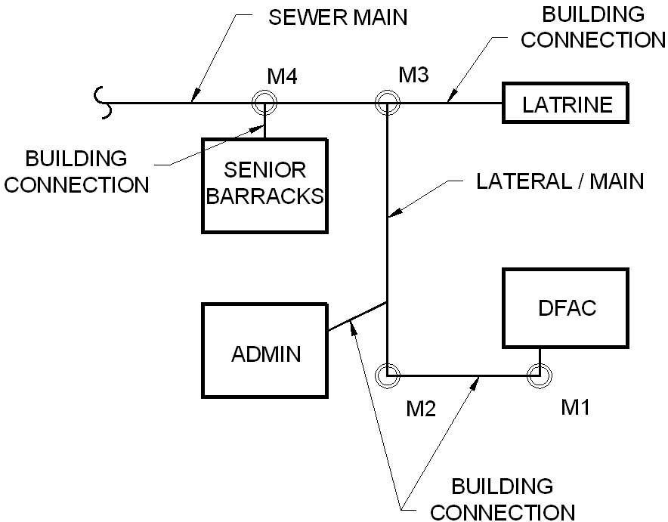

**Figure 2. Schematic Pipe Definitions**

**e) Pipe, Fittings and Connections**. Pipe, fittings and connections shall conform to the respective specifications and other requirements as listed in Contract Section 01015 and all of its referenced codes.

**f) Manholes.**

(1) The distance between manholes must not exceed 120 meters in sewers of less than 450 mm in diameter. For sewers 450 mm in diameter and larger, a spacing of up to 180 meters is allowed provided the velocity is sufficient to prevent settlement of solids.

(2) For pipe connections, the crown of the outlet pipe from a manhole will be on line with or below the crown of the inlet pipe. Where conditions are such as to produce unusual turbulence in the manhole, it may be necessary to provide an invert drop to allow for entry head, or increased velocity head, or both. Where the invert of the inlet pipe would be more than 450 millimeters above the manhole floor, a drop connection will be provided.

(3) Manhole frames and covers must be sufficient to withstand impact from wheel loads where subject to vehicular traffic. Covers with nominal sides measuring 762 mm or larger shall be installed where personnel entry may occur. Cover frames and/or heavy duty hinges shall prevent covers from dropping into the manholes, or circular covers shall be provided.

(4) The following construction practices will be required: 1) Smooth flow channels will be formed in the manhole bottom. Laying half tile through the manhole, or full pipe with the top of the pipe being broken out later, are acceptable alternatives; 2) for manholes over 1 meter in depth, one vertical wall with a fixed side-rail ladder will be provided; 3) drop connections will be designed as an integral part of the manhole wall and base; 4) in areas subject to high groundwater tables, manholes will be constructed of materials resistant to groundwater infiltration.

(5) The primary construction materials to be used for manhole structures are precast concrete rings and cast-in-place, reinforced concrete. Cast-in-place construction permits greater flexibility in the configuration of elements, and by varying reinforcing the strength of similar sized structures can be adjusted to meet requirements. In general, materials used should be compatible with local construction resources, labor experience, and should be cost competitive. Concrete shall have a 21 MPa minimum compressive strength at 28 days.

**g) Building Connections and Service Lines.** Building connections will be planned to eliminate as many bends as practical and provide convenience in rodding. Bends greater than 45 degrees made with one fitting shall be avoided and shall be made with combinations of elbows such as

45-45 or 30-60 degrees. Provide a cleanout at every combination of elbows.

**h) Cleanouts**. Cleanouts provide a means for inserting cleaning rods into the underground piping system. Install a cleanout within 2 meters of a building on all sewer building connections. A manhole may be used in lieu of a cleanout. An acceptable cleanout will consist of an upturned pipe terminating at, or slightly above, final grade with a plug or cap. Preferably the cleanout pipe will be of the same diameter as the sewer pipe, but never smaller than 150 mm.

**i) Grease Interceptors.** Grease interceptors are used to remove grease from wastewater to prevent it from entering the sanitary sewer and septic systems. All Dining Facilities (DFACs) shall drain DFAC cooking and sink and floor drain waste to a grease interceptor prior to the sanitary sewer system. The grease interceptor shall connect to the sanitary sewer system. Sanitary wastes from the DFAC shall flow in a separate pipe to the sanitary sewer system and shall not flow into the grease interceptor.

The grease interceptor shall either be a gravity type or hydro-mechanical type. If the designer selects a gravity type, the grease interceptor shall be of reinforced cast-in-place concrete, reinforced precast concrete or equivalent capacity commercially available steel, with removable three-section, 9.5 mm checker-plate cover, and shall be installed outside the building. Concrete shall have 21MPa minimum compressive strength at 28 days. Steel grease interceptors shall be installed in a concrete pit and shall be epoxy-coated to resist corrosion as recommended by the manufacturer. For sizing of the grease interceptor, follow the guidance provided in the AED Design Guide which is based on the EPA document 625/1-80-012 Onsite Wastewater Treatment and Disposal Systems.

If the designer selects a hydro-mechanical type, the grease interceptor shall be sized and tested in accordance with Standard PDI- G101, Testing and Rating Procedure for Type I Hydro- Mechanical Grease interceptors with Appendix of Installation and Maintenance.

Drainage to grease interceptors shall be separate and distinct from other sanitary sewer lines. Wastes that do not required treatment or separation shall not be discharged into any interceptor or separator, per ICC IPC 2007 Section 1003.2 Approval.

**j) Oil Water Separators.** Design and install oil water separators per the AED Design Guide which is based on the ICC IPC 2007 Section 1003.4.2 Oil Separator Design.

**k) Field Tests and Inspections.** Prior to burying the sewer lines, field inspections and testing shall be done to ensure the lines were properly installed and free of leaks. When conducting tests and inspections the following steps shall be conducted:

(1) Check each straight run of pipeline for gross deficiencies by holding a light in a manhole; it shall show practically a full circle of light through the pipeline when viewed from the adjoining end of the line. When pressure piping is used in a non-pressure line for non- pressure use, test this piping as specified for non-pressure pipe.

(2) Test lines for leakage by either infiltration tests or exfiltration tests.

(3) Deflection testing will not be required however; field quality control shall ensure that all piping is installed in accordance with deflection requirements established by the manufacturer.

**4. Septic System**

**a) General.** When determining an appropriate septic tank location, the Contractor shall provide protection for the septic system by ensuring that vehicles, material storage and future expansion shall be kept away from the area. Signage or other prevention methods (i.e., pipe bollards) shall be used to provide this protection. The finished grade for the site shall ensure that storm water runoff shall drain away from the site to prevent ponding, inflow and infiltration. Once an appropriate site is located, the Contractor shall conduct soil investigations for the site to determine ground water levels, soil conditions and the percolation rate.

**b) Septic Tank.** Septic tanks are buried, watertight receptacles designed and constructed to receive and partially treat wastewater. The tank separates solids from the liquid, provides limited digestion of organic matter, stores solids, and allows the clarified liquid to discharge for further treatment and disposal. Settleable solids and partially decomposed sludge accumulate at the bottom of the tank, while scum rises to the top of the tank’s liquid level. The partially clarified liquid is allowed to flow through an outlet opening position below the floating scum layer. The clarified liquid will be disposed of to the absorption field for further treatment and disposal.

Factors to be considered in the design of a septic tank include tank geometry, hydraulic loading, inlet and outlet configurations, number of compartments and temperature. If a septic tank is hydraulically overloaded, retention time may become too short and solids may not settle properly.

For Afghanistan, a baffled multi-compartment or dual chamber design shall be utilized. Refer to

Attachment A for further details. The septic tank shall be designed with a length-to-width ratio of

2:1 to 3:1 and the liquid depth should be between 1.2 meters and 1.8 meters. This depth is determined by the outlet pipe invert elevation. If not specified in the contract, the septic tank shall be sized based on the ADF, an additional 100% for sludge storage capacity and peak flows (0.8*c*ADD*CF*2). The tank shall be constructed of reinforced, cast-in-place concrete, with a minimum compressive strength of 21MPa at 28 days. Wastewater influent and effluent shall

enter and exit on the short sides of the tank, which will allow the wastewater longer detention and settling time. The baffled tank shall have two compartments, with the first compartment (influent entry point) having 2/3 thirds the volume capacity of the tank. The tank shall have a minimum earth backfill cover of 300 mm. Access shall be provided at the entry (influent) and exit (effluent) points of the tank by installing reinforced concrete risers, with steel access hatches, that will rise

50 mm above the finished grade. The following is an example of how to determine the volume and dimensions of the septic tank:

***Example 2: Size a Septic Tank - Size a septic tank for a design population of 120 individuals.***

*-Assume that tank volume and dimensions are not specified in the contract documents.*

*V = ADD*0.8*c*2*CF*

*=190 (liters/capita/day)*0.8*120(capita)*2(sludge retention)*1.5(capacity factor)*

*=* ***54,720 liters (54.72 m3)***

*Where,*

*ADD = Average Daily Demand (Water Flow) per Person (liters/capita/day)*

*0.8 = conversion of water use to sewage flow c = design population (capita)*

*2 = represents an additional 100% storage for sludge and peak surges*

*CF= Capacity Factor from UFC 3-240-09FA Domestic Wastewater Treatment*

*V = Volume (cubic meters)*

*-Assume 1.8 meter liquid depth and a length-to-width ratio of 2:1.*

*A = V/1.8 meters (liquid depth) = 54.72 (m3)/1.8 (meters) = 30.4 m2*

*LW = A*

*2W*(W) = 30.4 (m2) W2 = 30.4 (m2)/2*

*W = (15.2 m2)1/2 = 3.90 meters (3900 mm*)*

*L = 2*W = 2*3.90 meters = 7.80 meters (7800 mm*)*

*Inside dimensions of tank =*  ***7800 mm X 3900 mm X 1800 mm (liquid depth)***

*where,*

*A = Area*

*L = Length (meters) = 2*W W = Width (meters)*

*\*Always round up to the nearest 100 mm for final septic tank dimensions.*

**c) Absorption Field.** Absorption fields (also termed “leach fields”) are used, in conjunction with septic tank treatment, as the final treatment and disposal process for the septic system. Absorption fields normally consist of perforated distribution pipe laid in trenches or beds that are filled with rock. Refer to Attachments B or C for minimum perforation requirements. The septic tank effluent is distributed by the perforated pipe and allowed to percolate through the ground, where it is filtered and treated by naturally occurring bacteria and oxygen. Maximum depth for leach field percolation pipe lines shall be one (1) meter to allow for air exchange with the surface.

Once effluent is released from the septic tank, it travels by gravity through a solid 100 mm diameter PVC pipe, at a minimum 1.0% slope, to the distribution box. The distribution box is a reinforced concrete structure that distributes the septic tank effluent evenly throughout the absorption field through several 100 mm diameter perforated pipes. The distribution pipe is placed at a depth between 650 mm to 1500 mm. Because of the desire for the effluent to be distributed evenly over the absorption trenches or beds, the perforated pipe shall have a maximum slope of 0.5% and shall be capped at the end of each pipe. Generally, distribution piping is spaced from one meter to 1.8 meters apart and is no longer than 30 meters.

Absorption trenches are a minimum 610 mm wide but can be widened to shorten the length of the trench. A bed can be as wide as needed based on the total area needed for absorption, but maybe limited in size due to available real estate, or by construction constraints. Large

absorption beds are susceptible to the bed bottom being compacted during excavation and pipe installation. Compaction of the bed bottom will degrade percolation and may lead to failure of the absorption field. The absorption field has three (3) zones:

(1) The first zone is the absorption zone, which is the layer of in-situ material that filters and treats the effluent. This zone is determined to be suitable material for wastewater treatment based on the percolation test results, with a minimum thickness of 600 mm. Below the absorption zone, the material is considered unsuitable soil or bed rock or the seasonal water table is too high. If percolation tests determine that there isn’t a minimum 600 mm of suitable soil, the Contractor can remove the unsuitable soil to the desired depth and replace it with material determined to be suitable; however, the Contractor must get approval from the COR before attempting this.

(2) The second zone is the drainage zone, which is a 300 mm thick layer of rock fill, where the distribution pipe network lies. The bottom of this zone is filled with a minimum 150 mm of

19 mm to 38 mm diameter rock. The perforated distribution pipe is laid on top of the rock. A minimum of 50 mm of rock is placed carefully over the pipe network, and then a semipermeable membrane (geotextile fabric) is placed over the rock to prevent fine-grained backfill from clogging it.

(3) The final zone is the backfill zone. This is the upper most part of the absorption field, where backfill material is placed and is a minimum 500 mm thick. The backfill material protects the lower lying zones from storm water infiltration and freezing. The Contractor shall leave a mound of backfill material above the desired finished grade to allow for settlement.

Table 2 lists percolation rates and the corresponding sizing factor (m2/liters/day). The sizing factors are used, in conjunction with average daily flow (ADF), to determine the size of the absorption field. The following is an example of how to calculate the absorption field size for trenches and beds:

***Example 3: Size of Absorption Field - Size an absorption field (trench type) for a facility with an average daily flow of 27,360 liters/day and a percolation rate of 50 minutes.***

*A=Average Daily Flow*Water Absorption of Soil*

*=27,360 liters/day*0.054 m2/liters/day=* ***1,477.44 m2***

*where,*

*A = Area footprint needed for the absorption field (m2) Average Daily Flow (liters/day)*

*Water Absorption of Soil = By looking below, at Table 2, a percolation rate of 50 minutes falls in the 46 to 60 row and the correlating sizing factor is determined to be 0.054* m2/liters/day*.*

*Dimensions for trenches:*

*-Assume a 0.9144 meter wide trench bottom.*

*-Assume maximum trench length to be 30 meters.*

*\*N = A/(T *T ) = 1,477.44 m2/(0.9144 m*30 m) = 53.86 say:* ***54 Trenches (0.9144 meters X 30 meters)***

*T w L*

*where,*

*NT = Number of Trenches Tw = Trench width (meters) TL = Trench Length (meters)*

*\*Note: Trench bottom area can be reduced by 20 percent, if 305 mm of rock is placed below the distribution pipe. The area can be reduced by 34 percent for 457 mm of rock being placed below the pipe and by 40% for the maximum rock depth of 610 mm. Keep in mind that the additional rock added below the distribution pipe adds additional thickness required for the drainage zone. For example, where normally 150 mm of rock is placed below the pipe for a total 300 mm thickness for the drainage zone. Placing 305 mm of rock is placed below the pipe increase total thickness for the drainage zone to 455 mm of rock, (305 mm below the pipe; 100 mm around the pipe; and 50 mm above the pipe).*

*Dimensions for bed:* ***(Absorption Beds are not recommended for large systems due to the difficulty of constructing the bed bottom without compacting or disturbing it, and relative inability to function over terrain at various elevations.)***

***Absorption Bed Design Population of Twelve:***

*Average Daily Flow = 190 lpdc*0.8*12*1.5 = 2,736 lpd*

*Area Required = 2,736 lpd * 0.054 m2/liter/day = 147.74 m2*

*Absorption Bed Dimensions = A1/2 = (147.74 m2)1/2 = 12.15 meters, say: 13 meters per side*

*Absorption Bed Dimensions =* ***13 meters X 13 meters***

Refer to Attachments B and C for further design details of absorption fields.

**Table 2. Soil Treatment Areas in Square Meters.**

|  |  |
| --- | --- |
| Percolation Rate, Minutes for Water to Drop 25 mm | Water Absorption of Soil  (m2/liters/day) |
| Faster than 0.1 | Soil too coarse for sewage treatment |
| 0.1 to 5 | 0.020 |
| 6 to 15 | 0.031 |
| 16 to 30 | 0.041 |
| 31 to 45 | 0.049 |
| 46 to 60 | 0.054 |
| Slower than 60 | Soil too fine for sewage treatment |

**d) Pressure Dosing of Leach Fields.** Pressure dosing tanks are required per Unified Facilities Criteria (UFC) 3-240-09a, Domestic Wastewater Treatment, dated January 2004, Chapter 6, Section 6-2. Dosing tank (also known as a dosed system or Pressure Distribution System, PDS) is recommended for treatment systems with over 10 or more population equivalents and is preferred where backup power is available in larger systems in lieu of using more than one effluent gravity distribution box. No more than seven leach field laterals shall be connected to one effluent gravity distribution box.

PDS provides simultaneous distribution of sewage effluent over the entire infiltration surface. This enhances soil treatment by maintaining unsaturated soil conditions and inhibits failure by clogging. Dosing helps to maintain aerobic conditions in the soil, but this benefit would be negated if the infiltration surface is installed greater than 3 feet (1meter) below the ground surface. It improves the performance and increases the lifespan of the tile field. Pumping which is usually associated with dosing tanks provides flexibility in locating disposal fields where soil conditions are most suitable. Components of a PDS system are shown in Figure 2.

PDS SYSTEM COMPONENTS

1) Septic Tank or Holding Tank -Domestic sewage is transported to a septic tank. Septic tanks are to be comprised of two chambers and should be as per Paragraph 4(b) above. Septic tanks should be secured against hydraulic uplift in areas that have the potential for high groundwater levels. They should be adequately sealed to prevent the infiltration of groundwater to the sewage disposal systems or the exfiltration of sewage to the surrounding environment.

2) Pump - Pump should not be able to pump solids as large as the lateral orifice diameter with the impellers being of cast iron or other corrosion resistant material. Pumps should be serviceable from ground level without the need to enter the pump chamber or cut the pipe. The pump should have a quick release fitting to allow for easy removal and installation of the pump for maintenance purposes.

screen with 3.175mm (0.125 in) diameter holes. The screen should have a sufficient surface area so that the velocity of the sewage effluent passing through the screen does not allow the screen to become plugged with solids.

4) Pump Chamber - A pump chamber separate from a septic tank is required for PDS. The pump chamber shall be sized to allow a set volume of sewage.

5) Control Panel - All pumps shall be connected to a control panel. The panel should have an alarm in case the pump fails to operate properly.

6) Transport Pipe - The transport pipe is the pipe that connects the sewage effluent pump to the manifold pipe. The diameter of this pipe is determined by friction losses caused by

the flow of sewage effluent through the pipe and by the desire to have a cleansing velocity where possible of 0.6 m/s (2 ft/s) passing through the pipe during operation. There should be a flexible connection between the pump and the transport pipe to allow for the possible settlement of the pump chamber or the septic tank after installation. The PVC pipe shall conform to ASTM D2241 PVC Pressure-Rated Pipe (SDR series) and have a maximum SDR of 35.

7) Manifold Pipe - The manifold pipe is located between the transport pipe and the laterals in the leach field. This pipe is sized so that there is no more than a 15% variation in the rates of discharge between the first and last orifices in the network. The PVC pipe shall conform to ASTM D2241 PVC Pressure-Rated Pipe (SDR series) and have a maximum SDR of 35.

8) Lateral Pipe - Laterals in the PDS are used to distribute the sewage effluent to the soil.

Their length configuration and number are determined by soil condition, percolation rate and leach field geometry. The diameter of a lateral should be the smallest diameter that achieves nearly uniform pressure along the entire length of the lateral. The PVC pipe shall conform to ASTM D2241 PVC Pressure-Rated Pipe (SDR series) and have a maximum SDR of 35.

9) Orifice - Orifice shields are placed over the orifices (holes) in the laterals to prevent sewage effluent from being forced under pressure to the surface of the drain field when the orifices are in the 12 o’clock position (the crown of the lateral). They also prevent the orifices from becoming blocked by drain rock in the leach field. The shields will be

asphalt building paper; minimum of 0.73 kg/m2 or geotextile material.

Clean outs - Clean outs shall be placed at the ends of the laterals, a minimum of 0.5 meter above ground. They should have treaded caps at their ends to allow for inspection and cleaning of the laterals. In cold climates they should be insulated to prevent the laterals from freezing.

**Figure 3. Pressure Distribution System (Source: Washington State Department of Health.)**

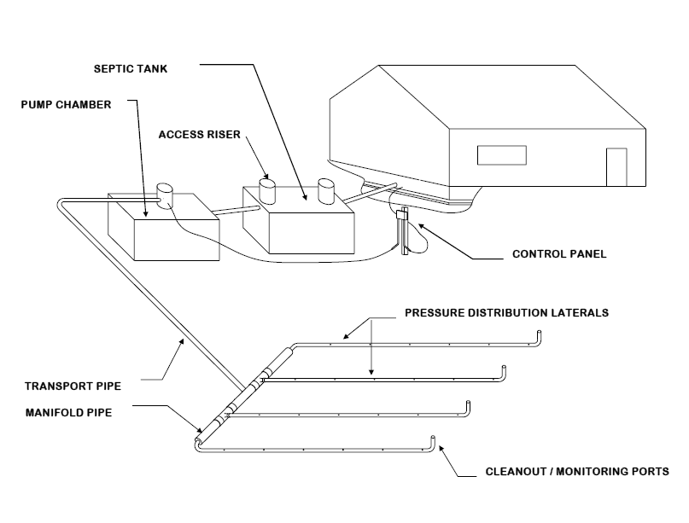

Many project septic designs rely on gravity flow from the septic tank outlet to a distribution box (not shown in Figure 2) which serves the function of the manifold pipe. The gravity dosing concept requires a very level leach field and favorable soil characteristics for absorption (sandy gravelly soil) in order to provide long term treatment.

Pressure dosing applies the effluent over the entire absorption area in such a way that the hydraulic loading is more evenly distributed thus promoting better soil treatment by maintaining vertical unsaturated flow and reducing the degree of clogging in finer textured soils. It can be applied to sloping sites but will require an additional features (in addition to other PDS components) shown in Figures 2 and 3. These figures show manifold and automatic dosing valve that operates using hydraulic pressure to change the distribution line that receives the effluent each time the effluent pump cycles in the dosing tank.

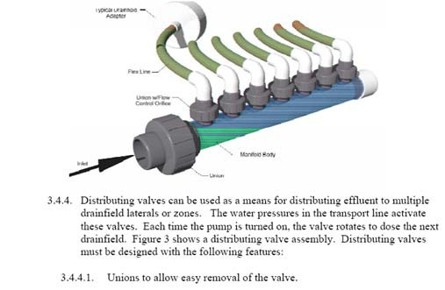

**Figure 4. Typical Pressurized Flow Distribution Device**

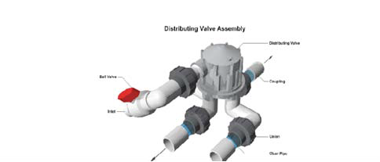

**Figure 5. Typical Flow Distribution Valve**

Pressure distribution would permit the use of sloping sites as seen in the following schematic:

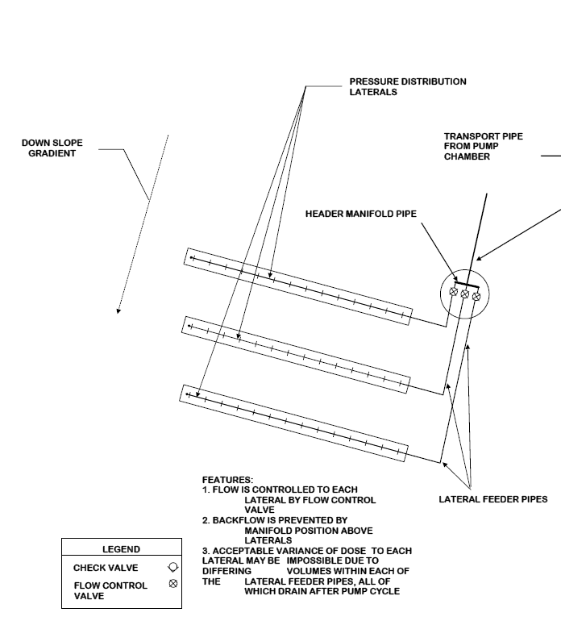

While there are additional operational costs associated (valve cleaning and occasional replacement), the advantages for sloping sites include:

• Lower cost of leveling the site

• Avoiding the destruction of the natural soil horizon and the microbes that promote the biological treatment of the wastewater effluent

• Ground water recharge of the aquifer where water is being drawn

• Use previously unusable sites where the alternative (holding tanks or package WWTP)

are more costly

• More frequent smaller doses assure unsaturated flow through the soil and reduce the potential for clogging and destroying the treatment capacity of the site.

b) PDS SYSTEM DESIGN EXAMPLE STEPS

The following design example is based on information prepared by Professor James Converse, dated 2000 (reference 3). The designer is recommended to review all reference material listed at the end of 4 (d) as well as apply his/her engineering judgment. Units are shown as imperial, however can be easily converted to “soft” metric.

Design is a two part process:

PART 1 consists of sizing the distribution network which distributes the effluent in the aggregate and consists of the laterals, perforations (orifice) and manifold.

PART 2 Consists of sizing the force main, pressurization unit and the doze chamber and selecting controls.

Within each part, there are several steps associated with design.

***Example 4: Size a pressure distribution network with the following given information: (units are in imperial units)***

Absorption area – 113ft long by 4 ft wide

Force Main – 125 ft long Elevation Difference – 9 ft Number of elbows - 3

**Part 1. Design of the distribution network.**

Step 1. **Configuration of the network.**

This is a narrow absorption unit on a sloping site.

Step 2. **Determine the lateral length.**

Use a center feed (meaning the manifold for the line from the dosing tank is in the center of the absorption field), the lateral length is:

Lateral length = (B/2) – 0.5 ft

Where B = absorption length. (113/2) – 0.5 = 56 ft

Note: Recommend to have the manifold down the center of the absorption field and then have laterals going out from the center.

Step 3. **Determine the perforation spacing and size**.

Each perforation will cover 6ft2/orifice (note: this value is a based on rule of thumb for 30-36” orifice spacing). This value is the area/orifice

parameter. This means, each orifice will discharge an equivalent effluent

on a 2ft x 3 ft area.

Will use two laterals on each side of the center feed.

Spacing = (area/orifice x number of laterals / (absorption area width). Spacing = (6ft2 x 2/(4ft)) = 12/4 = 3 ft

Size – use either a 3/16” or ¼” diameter. Recommend using a 3/16” diameter orifice. Whichever diameter is used, it requires placement of an effluent filter (screen, such as wire mesh at the outlet pipe) in the septic tank to eliminate carryover of large particles. Designer can choose to use larger or smaller diameter, (refer to reference 3 for other sizes).

Step 4. **Determine the lateral diameter.**

Refer to the following figure, “Orifice Spacing in Feet” for a 3/16” diameter orifice.

**Figure 6. Orifice Spacing**

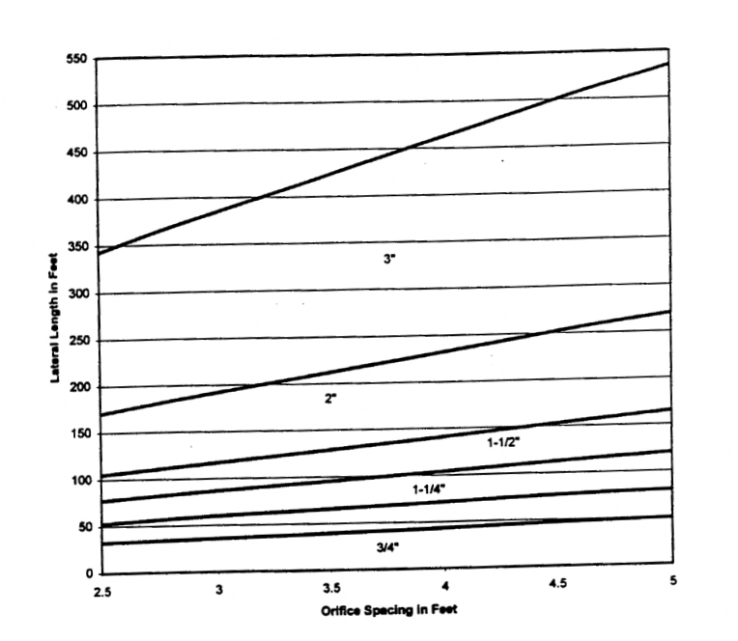

Using lateral length of 56 feet and orifice spacing of 3, the point of intersect is between the 1-1/4” and 1-1/2” lines. Round up to the next value, therefore it will be 1-1/2”.

In this design example, the lateral diameter is 1.5”

Step 5. **Determine number of perforations per lateral and number of perforations.**

Using 3 feet spacing in 56 feet length yields:

N = (p/x) + 0.5 = (56/3) + 0.5 = 19 perforations/lateral

Number of perforations = 4 laterals x 19 perforations/lateral = 76. Check: Maximum of 6 ft^2/perforation

Number of perforations = (113 ft x 4 ft)/6ft^2 = 75 , so OK.

Note: Perforation is the same as orifice. The 4 laterals correspond to two laterals on each side of the center manifold.

Step 6. **Determine lateral discharge rate (LDR).**

Using network pressure (distal) pressure of 3.5 ft and 3/16” diameter perforations, using the table below, gives a discharge rate of 0.78 gallons per minute (gpm) regardless of the number of laterals.

Table A -1 Orifice Diameter

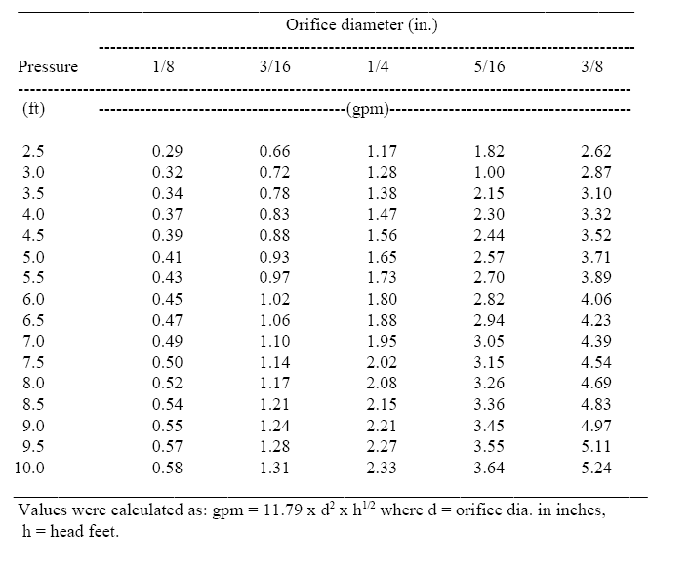

Note: The value 3.5 ft for distal pressure corresponds with 3/16”

diameter orifice.

LDR = 0.78 gpm/perforation x 19 perforations = 14.8 gpm

Step 7. **Determine the number of laterals.**

This is already completed in steps 3 and 4.

Total of four laterals, two on each side of the manifold. The spacing between laterals to be at 2 ft apart.

Step 8. **Calculate the manifold size.**

This is the same size as the force main, the line from the dosing tanking out to the absorption field. Since the diameter of the laterals are 1.5

“(see step 4), the force main and the manifold should be at least half size larger, say 2” diameter.

Step 9. **Determine network discharge rate (NDR).**

NDR = 4 laterals x 14.8 gpm/lateral = 59.2 gpm. Round up to 60 gpm. This is the value that will be utilized in Part 2 when sizing for a pump.

Step 10. **Provide for flushing of laterals.**

Provide cleanouts at the end of each lateral line as well as at the end of the manifold. This will allow for ease of maintenance.

**Part 2. Design of Force Main, Pressurization Unit, Dose Chamber and Controls.**

Step 1. **Total Dynamic Head (TDH)**

The total dynamic head is the sum of the following: System head + Elevation head + Head Loss = TDH

System Head = 1.3 x distal head (ft)

SH = 1.3 (3.5) = 4.55 ft. (Note: distal head of 3.5 comes from Step 6

Part 1. This value is a rule of thumb).

Elevation Head = (pump shut off to network elevation) this is also the static head. Will depend on the design invert elevations.

Head Loss due to friction = This is the sum of losses due to fittings and pipe run.

For fittings and friction loss, use the two tables below.

For 2” diameter fittings the friction loss for the 90 degree elbow is 9. Since we have three elbows (in the problem statement) the total head loss due friction from fittings is 27ft.

Below is the friction loss table to use for our problem. In our example,

the flow rate is 60 gpm and the nominal pipe size of the manifold and the force main is 2-inches in diameter. Therefore, the friction loss per 100 feet of pipe is 7. This value will depend on the size and type of pipe

used in design. Refer to a standard fluids/hydraulics references for values other than given below.

Table A-2. Friction loss in plastic pipe.

Flow

Nominal Pipe Size

|  |  |  |  |  |  |  |
| --- | --- | --- | --- | --- | --- | --- |
| (gpm) | 3/4 | 1-1/4 | 1-112 | 2 | 3 | 4 |

2

3.24

4 5.52

*5* 8.34

6 11.68 2.88

7 15.53 3.83

8 19.89 4.91

9 24.73 6.10

10 30.05 7.41

II 35.84 8.84

12 42.10 10.39

13 48.82 12.04

14 56.00 13.81

15 63.63 15.69

16 71.69 17.68

17 80.20 19.78

18 21.99

19 24.30

20 26.72

(Feet/100ft of pipe)

**Velocities in this area are below 2 fps.**

2.50

2.99

3.51

4.07

4.66 1.92

5.30 2.18

5.97 2.46

6.68 2.75

7.42 3.06

8.21 3.38

9.02 3.72

25 40.38

30 56.57

35

40

45

50

60

70

13.63 5.62

19.10 7.87

25.41 10.46

32.53 13.40

40.45 16.66

49.15 20.24

28.36

37.72

1.39

1.94

2.58

3.30

4.11

4.99

7.00 0.97

9.31 1.29

**80 Velocities in theses areas**

|  |  |  |  |  |
| --- | --- | --- | --- | --- |
| 90 | exceed I0 fps. which is too great | 14.81 | 2.06 |  |
| I00 | for various flows and pipe diameters | 18.00 | 2.50 | 0.62 |
| 125 |  | 27.20 | 3.78 | 0.93 |
| 150 |  |  | 5.30 | 1.31 |
| 175 |  |  | 7.05 | 1.74 |

11.91 1.66

Note: Table is based on - Hazen-Williams fonuula: h = 0.002082L x (100/C)L"x (gpml.85

/

) where: h = feet of head, L = length in feet, C= Friction factor from Hazen­ Williams (145 for plastic pipe), gpm = gallons per minute, d= nominal pipe size.

d48655

Table A-3. Friction losses through plastic fittings in tenns of equivalent lengths of pipe. (Sump and Sewage Pump Manufacturers, 1998)

Type ofFittiug

---------------Nominal size fitting and pipe ------------------------

1-1/4 l -1/2 2 2-1/2 3 4

----------------------------------------------------------------------------------------------------------------------

|  |  |  |  |  |  |  |
| --- | --- | --- | --- | --- | --- | --- |
| 90° STD Elbow | 7.0 | 8.0 | 9.0 | 10.0 | 12.0 | 14.0 |
| 45° Elbow | 3.0 | 3.0 | 4.0 | 4.0 | 6.0 | 8.0 |
| STD. Tee  (Diversion) | 7.0 | 9.0 | 11.0 | 14.0 | 17.0 | 22.0 |
| Check Valve  Couplin  Quick Disconnect | 11.0  1.0 | 13.0  1.0 | 17.0  2.0 | 21.0  3.0 | 26.0  4.0 | 33.0  5.0 |
| Gate Valve | 0.9 | 1.1 | 1.4 | 1.7 | 2.0 | 2.3 |

The total head loss due to friction is as follows:

7 (125 ft + 27 ft)/100 ft = 10.6 ft

Total Dynamic Head (TDH) = 4.5ft + 9 ft + 10.6 ft = 24.1 ft

Step 2. **Pump Summary.**

Pump must discharge 60 gpm against a head of 24.1 feet with 2” force main.

These are the calculated flow and head values. The actual flow and head will be determined by the pump selection. A system performance curve plotted against the pump performance curve will give a better estimate of the flow rate and total dynamic head the system will operate under.

Step 3. **Determine the dose volume.**

For dose volume, use 5 times the lateral void volume. Void volume is selected from the table listed below.

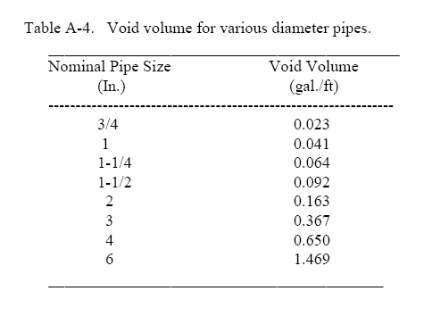

For 1.5” lateral line, the void volume is 0.092 gal/ft. For 2” force main line, the void volume is 0.163 gal/ft

Dose rate in laterals = 5 x 56ft x 4 laterals x 0.092 gal/ft

= 103 gal/dose

Dose rate in main line = 125 feet x 0.163 gal/ft

= 20.4 gal/dose

Dose rate total = 103 gal + 20 gal = 123 gallons/dose

There will be 5 doses at 123 gallons per dose throughout a 24 hour period. Step 4. **Size the dose chamber.**

Based on the dose volume, storage volume and room for a block beneath the pump and control space, 500- 700 gallon chamber will suffice.

Step 5. **Select controls and alarms.**

This example is for demand dosing. The controls will include on-off float and alarm float. The designer will set the on float based on the volume of the dose (123 gallons). The pump will dose five times through out the day.

**Figure 7. Example of a dosing tank (Source: Converse 2000)**

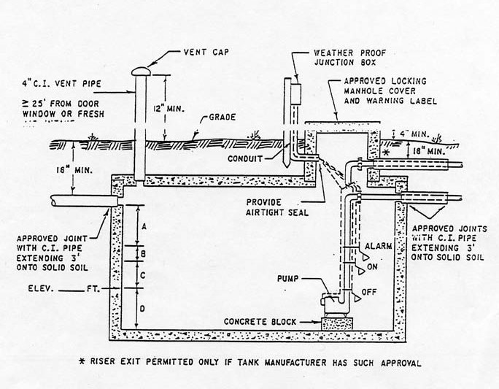

**e) Seepage Pits.** Seepage pits or dry wells are deep excavations used for subsurface disposal of pretreated wastewater (influent processed through a septic tank). Wastewater enters the chamber where it is stored until it seeps out through the chamber wall and infiltrates the sidewall of the excavation. Seepage pits are generally discouraged, in favor of trench or bed systems.

Seepage pits have been shown to be an acceptable method of disposal for very small wastewater flows. Seepage pits are used where land area is too limited for trench or bed systems ; and

either the groundwater level is deep at all times, or the upper .9 to 1.2 m of the soil profile is underlain by more permeable unsaturated soil material of great depth.

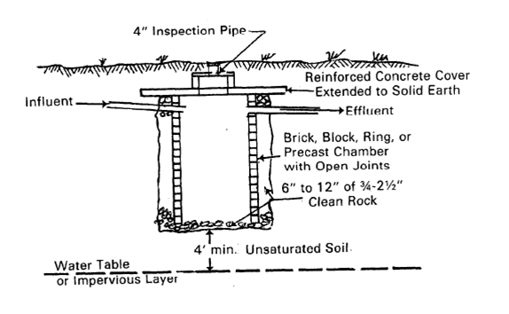

**Figure 8. Seepage Pit Cross Section**

The suggested site criteria are similar to those for trench and bed systems except that percolation rates slower than 12 min/cm are generally excluded. Maintaining sufficient separation between

the bottom of the seepage pit and the high water table is a particularly important consideration for protection of groundwater quality. Seepage pits bottoms shall be a minimum of 1.22 m (4 ft.) above the seasonally high water table as shown in Figure 7-9. In Afghanistan, marked and rapid swings in water table levels due to seasonal rains and flooding make prediction of appropriate seepage pit depth extremely difficult

Seepage pit sizing and the infiltrative surface of the pit shall be in accordance with Chapter 7

Disposal Methods, paragraph 7.2.3.3 Design, of EPA 625/1-80-012. Since the dominant infiltration surface of a seepage pit is the sidewall, the depth and diameter of the pit is determined from the percolation rate and thickness of each soil layer exposed by the excavation. A weighted average of the percolation test results is used for design. Seepage pits will require a labor intensive and more detailed soil percolation rate study for each of the distinct soil layers encountered in the excavation to its ultimate depth. Infiltration rates presented earlier in Table 2 are used to compute the necessary sidewall area. Table 7-6 can be used to determine the necessary seepage pit sidewall area for various effective depths below the seepage pit inlet.

***Example 5: Size of a Seep Pit – Based on a population of ten (10) and a percolation rate of***

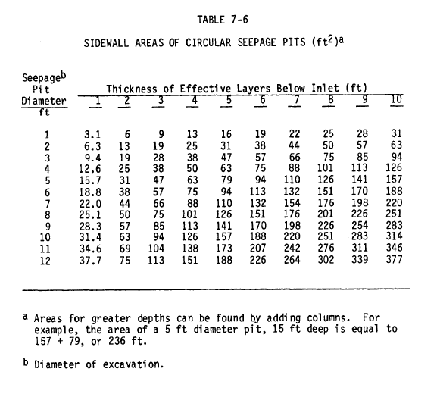

***6 min/cm.***

*ADF = 10 capita*190 liters/capita/day*0.8*1.5 capacity factor = 2,280 liters/day*

*Area Required = 2,280 lpd * 0.031 m2/liter/day = 70.68 m2 = 761 ft2*

*Seep Pit Size equals approximately 2 pits (A= 754 ft2) 3.66 m in diameter and 3 m deep below the inlet pipe.*

*The seepage pits should be separated by at least 2 diameters spacing between the sides of the pits.*

**This example shows that seepage pits when properly sized are not viable for larger wastewater flows.**

**5. Design Submittal Information**

**a) Gravity Sewer.** A preliminary sewer flow depths can be calculated assuming normal flow regime. This is a simplification of actual flow regime because there will be energy losses at the entrance of other side laterals and manhole energy losses that will make the water profile will not be uniform. If sewers are at flat grades for long pipe runs, these losses shall be considered because they will over the length of the project become a significant design factor. For short pipe runs and normal slopes (greater than minimum

slope values) the uniform flow assumption can be used. Design documentation for gravity sewer design using the uniform flow assumption shall include the following:

• Sewer pipe line number

• Pipe diameter

• Pipe length

• Pipe slope

• Incremental wastewater inflow

• Total cumulative wastewater flow

• Pipe roughness (n value)

• Full flow area of pipe

• Hydraulic radius and full flow velocity

• Calculation of ratio of actual design flow to full flow in the pipe

• Calculation of the actual design flow velocity for sewer pipe length

Flow velocities shall be compared to design standards and profiles or pipe size adjusted accordingly. An example analysis is shown in Appendix A.

c) **Pressure Distribution.** A series of design examples follows this section that illustrates the design submittal information required for pressure distribution systems (PDS) for effluent disposal in leach fields.

d) **Septic Tanks and Leach Fields.** Required design calculations to be submitted fro projects are shown in Examples 1 through 3 previously described.

**6. As-Builts**

Upon completion of installing the sanitary sewer and septic systems, the Contractor shall submit editable CAD format As-Built drawings. The drawings shall show the final product as it was constructed in the field, with the exact dimensions, locations, materials used and any changes made to the original design. Refer to Contract Sections 01335 and 01780A of the specific project for additional details.

Reference – Dosing tank:

1) Unified Facility Criteria 3-240-9a Domestic Water Treatment, January 2004 <http://www.wbdg.org/ccb/DOD/UFC/ufc_3_240_09fa.pdf>

2) Environmental Protection Agency (EPA) 625 R-00 008, February 2002 [http://www.epa.gov/safewater/uic/class5/pdf/techguide_uic-](http://www.epa.gov/safewater/uic/class5/pdf/techguide_uic-class5_2002_onsite_wwt_sys_man.pdf)

[class5_2002_onsite_wwt_sys_man.pdf](http://www.epa.gov/safewater/uic/class5/pdf/techguide_uic-class5_2002_onsite_wwt_sys_man.pdf)

3) Pressure Distribution Network Design by James C. Converse January 2000 <http://www.iowadnr.com/water/wastewater/files/dg_app_b_pdd.pdf>

4) Washington State Department of Health, publication # 337-022, July 2007 <http://www.doh.wa.gov/ehp/ts/WW/pres-dist-rsg-7-1-2007.pdf>

**Appendix A- Example Gravity Sewer Calculation**

**Example Gravity Sewer Calculation**

The objectives of the analysis for the system include:

1 Verifying the minimum diameter (without flowing more than 80% full) for the collection piping is large enough to convey flow throughout the system such that the technical criterion for minimum velocity is achieved. This is to be done with the necessary slope greater than the minimum grade that reduces settling of suspended solids and provides economical construction depth, without the need for excessive number of lift stations.

2 Verifying whether sewer drop structures are needed to achieve minimum cover at acceptable sewer grade on long pipe runs.

3 Verifying if there is a need for lift stations over long pipe runs.

4 Verifying the heights assumed for manholes are acceptable; generally less than 5 meters depth.

The project site plan is used to obtain pipe information for the calculations. See the attached site plan example. The analysis can be set up in an electronic spreadsheet format.

1 Organize a numbering system from upstream to downstream a. Enter hydraulic information for each pipe run

i. Pipe diameter ii. Pipe length

iii. Pipe slope

iv. Pipe roughness properties – Manning’s n value

b. Determine the flow added at each intersection that represents the downstream pipe discharge.

2 Add flows in the downstream direction and enter into a table containing the pipe information

3 Calculate the full flow capacity and velocity of the pipe runs a. Use Manning’s equation to calculate flow velocity

b. Calculate flow base on total flow area and velocity

4 Use a nomograph or flow properties chart (see attached) to calculate the proportional flow and velocity for the actual flow rate in each pipe based on the design flow

5 Check if the flow depth is less than 80% and the flow velocity exceeds the minimum required.

6 If not, try again

7 Tabulate the design information on the construction drawing sewer site plan in a pipe schedule



THIS EXAMPLE IS FOR AN

M11

ALL BUILDING

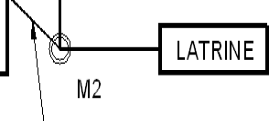

INSTALLATION OF 650 PERSONNEL(PN), FOR INSTALLATIONS WITH LESS THAN

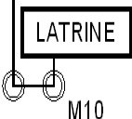

450 PN USE THE GUIDANCE FOUND

CONNECTIONS ARE AT 1%

WITHIN PAR AGRAPH 3.d.

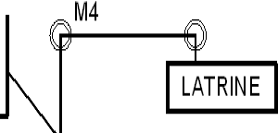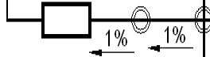

EXAMPLE SEWER LAYOUT FOR POPULATION >450

1.2

1

0.8

0.6

**d/D**

Qs/Qf

Vs/Vf

0.4

d/D =35%

0.2

0

0 0.2

Qs/Qf =0.25

START HERE

0.4 0.6 0.8 Vs/Vf =0.8

**QS/QF OR VS/VF**

1 1.2 1.4

**AED Design Requirements**

**Sanitary Sewer & Septic Systems**

**Appendix B – Drawing Detail**

Septic Tank Details

Absorption Bed and Trench Details

Dosing system Layout

SanitalY Sewer & Septic systems

• ¢ • •

*r* '-I

a

I!

! 0 -- !

il'

*rre* $' ..,f!l!, ; ,,!

..,..- -

,-'.".' I

ARSOB?TION FIB 0 QEIAII

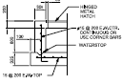

\!)



*TY P'" U '* 'ifC lmy

- -

O!STRI!UJJION BOX QEAi!l

=

·g s: · '9Fdi!i'f,t,.s,

l/, l.oXI( 01'AIMION$$WII.L MV!.A lttfGTH TO'.'I OTHRAT10Of'8ET'IIEEN l:lo\3. :1.

..

'

~~-~~

@ z5ffiRATED PI PE SECTI ON

'· n.la; t••u.•or u.... ...h>.

*.& '*-*t*-*f*-*u*(16*vo.*

*' t:'l"t*

*1*

·-:t...

,r-----

•• ..U" H- !t(I-Ol>o-to.U- . ' '

.occou"=f:.'J: ----_"\1

. l ''"'" 1.1



·_ ..f,.·

C....O...N.........E SFPT!C TANK PLAN VIEW

II 1 [:11=1P-.:·,."::.'.I

i



"'- -1----- -1"'-----..::1 K• -­

? .SETE SEPTIC TANK SECTION

llo)X "'--.e.. ...:.:w.o''"

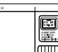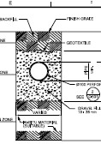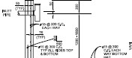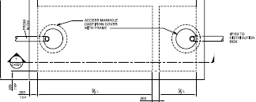

\MiiJIII(ffllifM

San ary Sewer & Septic Systems

• ¢ • •

I.O'I'QIJTOI'"-t«<"'r.M"CC>......«: I

w.rt _-.,.."..,,.._. ...'.

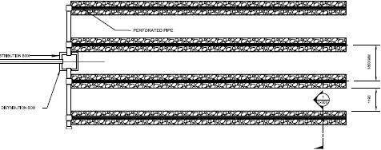

&..Y. ,,.,,.'.,....,ur..

I!.

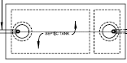

.Q.

·

-._·,_"'_' '"-o'""-u.



SEPTIC SYSTEM TRENCHCONFIGURATION PLAN VIEW

h '

-'--------

. .............. IOCI.Ii:.l.-........

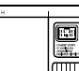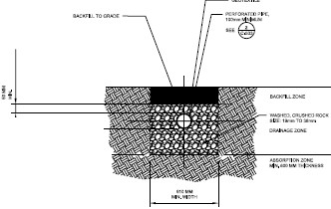

I>IACUfM:COI ,.....OO > 'IO«Wff\

>,................ "" ICY - < a>

Tll( tf"':.o$$1.,..,..

'•'-"'"H.:·..,-rt,,_..,,,""'""•

@Jff&Tz feSYSTEM TRENCH CONFI GURATI ON SECTI ON VI EW

A • • •

I • • •



C)lttef-**DQSI!!G TANK (pRfSSUBEDISTBIBUlJON sys"'EMlLAyocn**

(9 i ~~..~~R~~..~~E~~..~~S~~..~~$~~.~~U~~.~~ REDISlRIBUDONLATERAL W£ OR!BCE

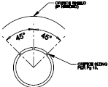

-_-.._1-')..­.

-..........

